Bulletin no. 30 – March/April 2023
Saying goodbye to Winter
Welcome to our latest bulletin

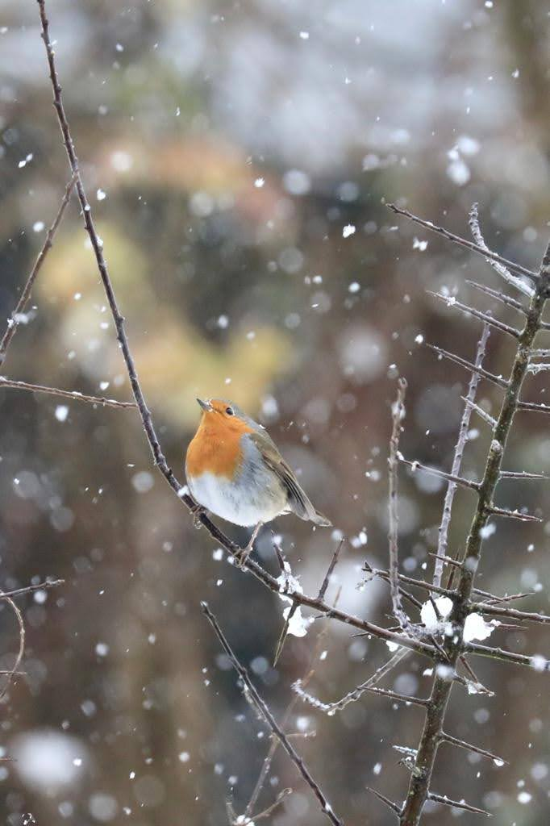 | 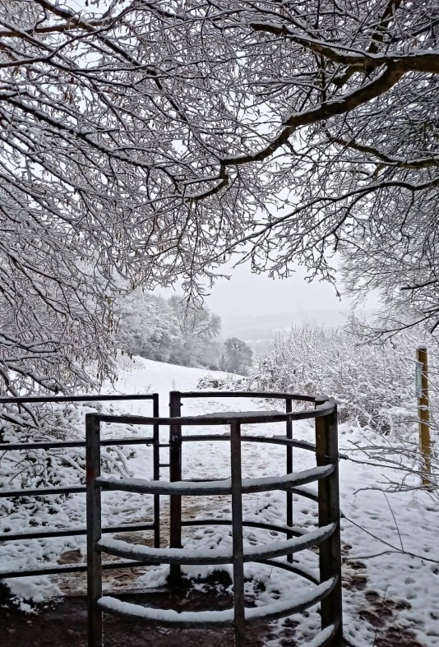

A final blast of winter on the fields – Photos: Claire McCormick and Peter McSweeney
“Frost-locked all the winter,
Seeds, and roots, and stones of fruits,
What shall make their sap ascend
That they may put forth shoots?”
from Spring by Christina Rossetti

Work was suspended for one session in March and many of our volunteers and visitors took the chance to enjoy the magical spectacle the fields bedecked in a blanket of beautiful snow.

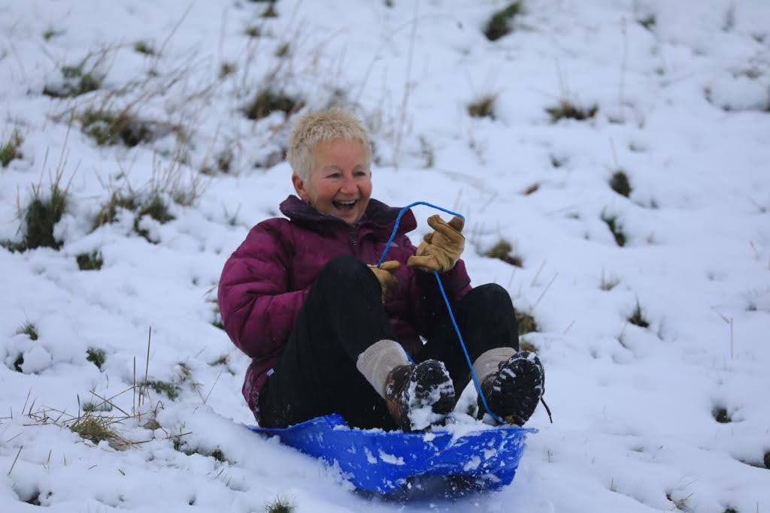

Jackie in front of the camera for a change – Photo Claire McCormick
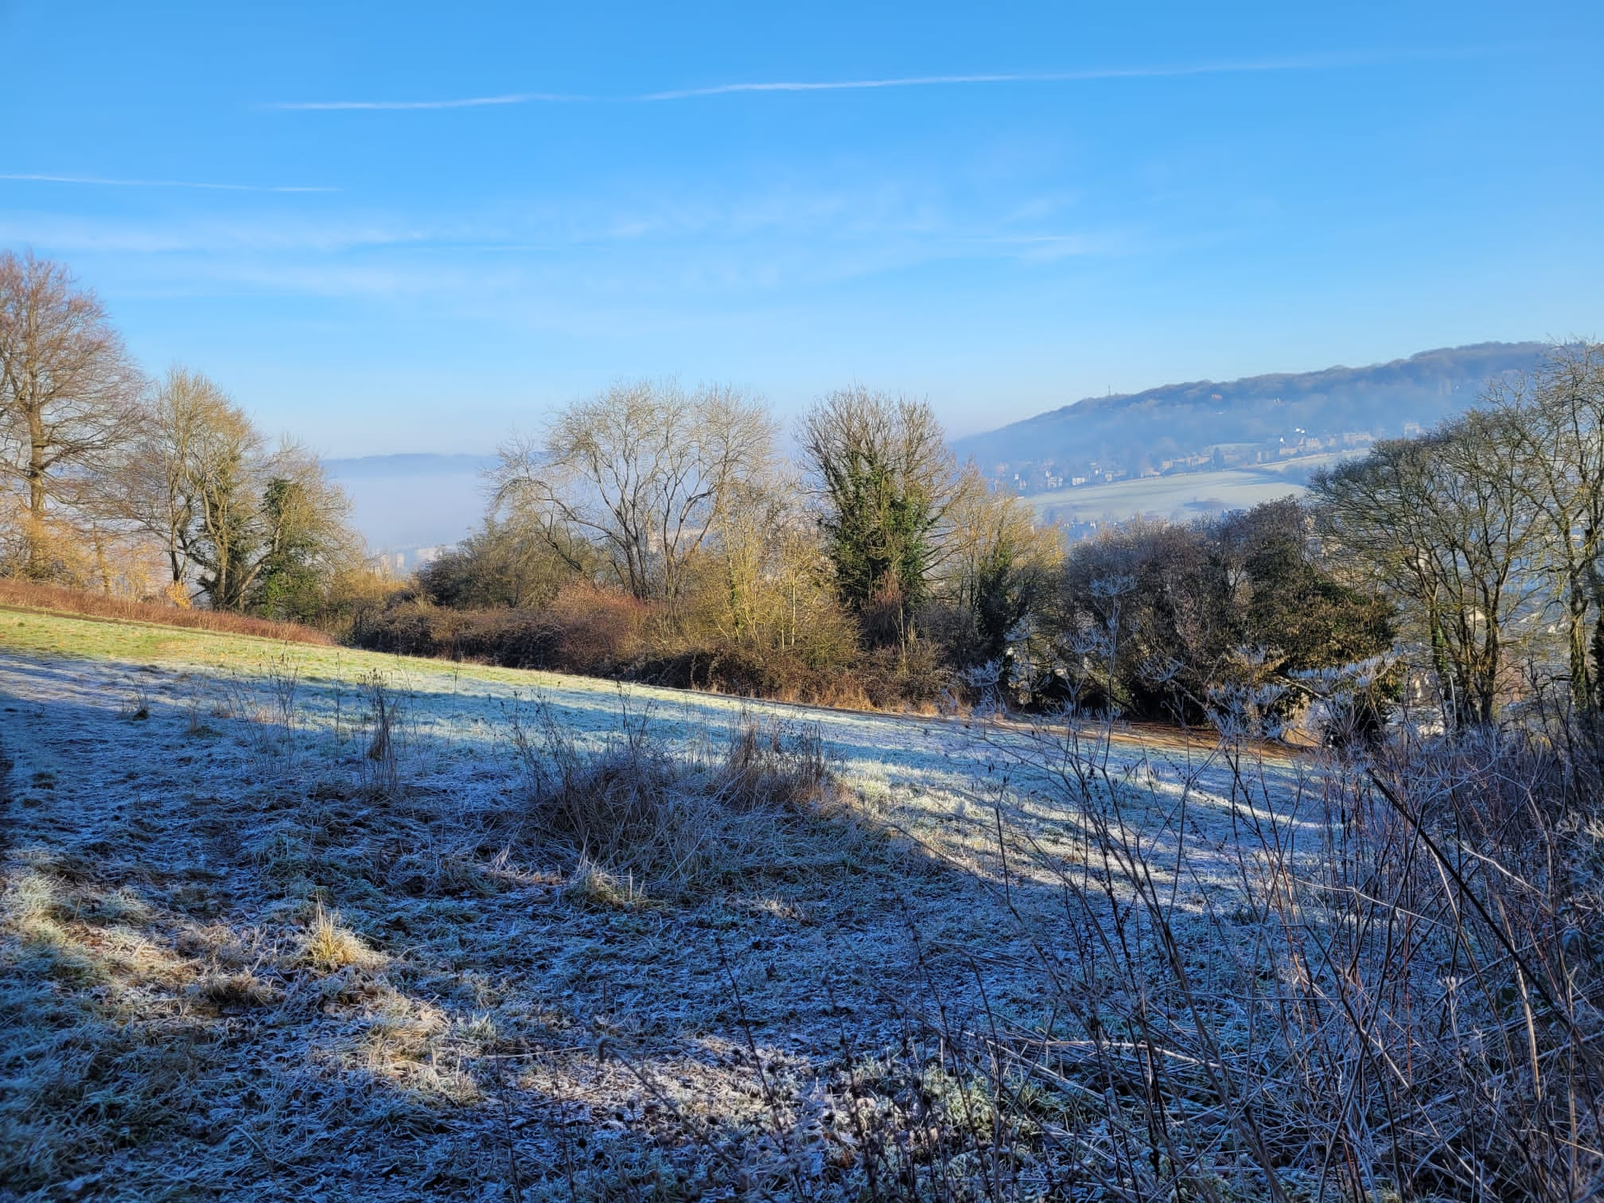

A crisp start to a beautiful day – Photo Jackie Terrett

What to look out for in March and April
In the older grassland areas of the fields there are large number of anthills, as revealed when we cut the grass carefully around them. These amazing mounds are the tops of complex underground colonies of around 1000 to 5000 yellow meadow ants (Lasius flavus), which feed mainly on the sweet honeydew of aphids that they farm in their chambers. Their earth domes help to regulate the colony temperature.
Small, delicate wildflowers plants find a space to grow on the anthills and green woodpeckers, which are specialist feeders on ants, might be seen probing the mounds. Badgers are often the cause of anthills being hollowed out, as they seek a hidden meal.
As days grow longer in April, warmer weather brings out a flush of grass, fresh green leaves on the hazels and sycamores and stars of white ramson flowers under their spreading boughs. Our native birds, such as blackbirds, robins and song thrushes, are blasting out their territorial songs, and are joined by some of our summer visitors, such as blackcaps and chiff chaffs...wonderful.
To get the full bird singing experience, a visit to LHF just before dawn on a calm day in spring will pay dividends, if you can bear the early start.

Peter McSweeney

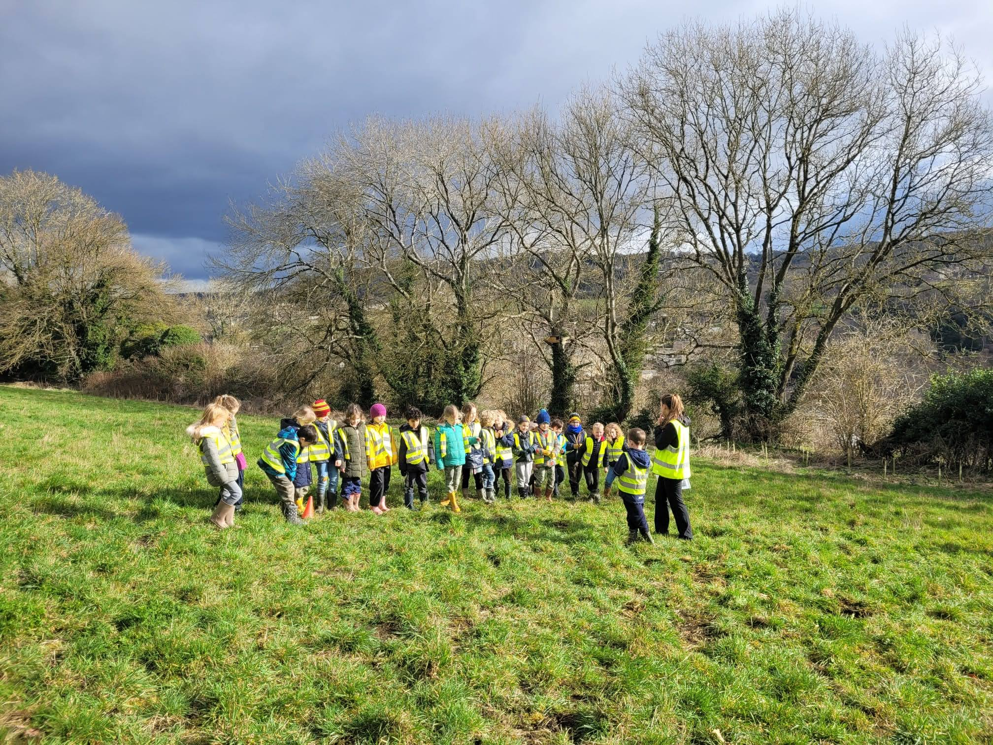
Infants receiving instruction - Photo: Chris Kinchin-Smith
Widcombe infant school visit

On Wednesday morning 1st March we had our first visit of the year from Widcombe Infant School. This comprised 60 children aged 6 and 7 (Year 2), led by their new leader for Forest School activities Katherine Wildy. Katherine was supported by several other teachers and parents, and by FLHF volunteers Chris, Jackie, Kate, Maya, Maurice, and Ruth.

The main activity was the planting of 100 snowdrop plants and 100 bluebell plants, along the hedgerow between the Inner Field and the Copse. These plants had been donated by Bath in Bloom. The children were split into three groups and each child planted 3 or 4 plants. There was also time for a game based on ‘Please Mr Crocodile, may I cross the water?”; and for a tour of the Fields where each group got as far as Tiny Forest 3, looking for signs of Spring.

We are now planning other future visits by children from Widcombe Infant and Junior schools, and from The Paragon School.

Chris Kinchin-Smith

Lyncombe Hill Fields RSPB Great British Birdwatch
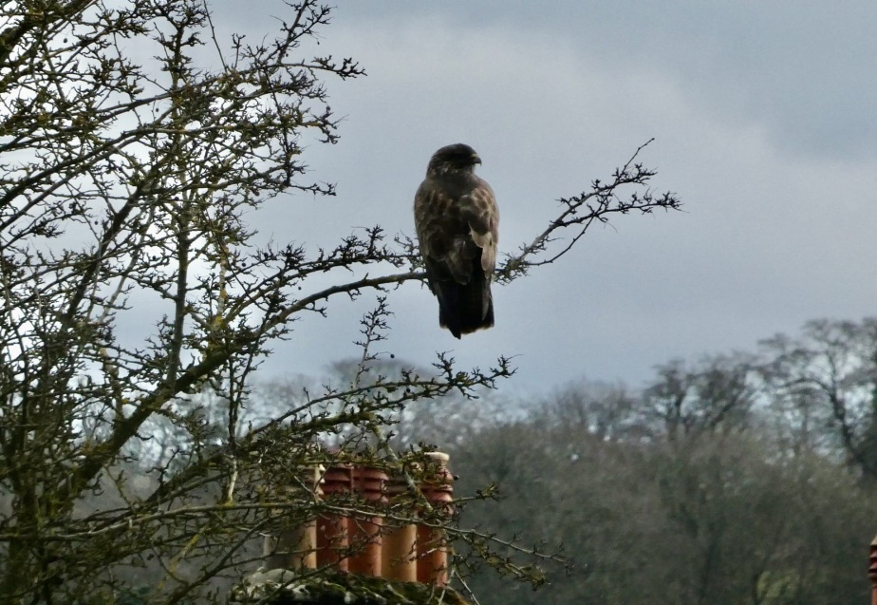
Our local buzzard carries out its own birdwatch – Photo: Jackie Terrett
The RSPB’s Big Garden Birdwatch has been running for 44 years. On LHF, we’ve participated for the last three, looking at the birds across all the fields for one hour between 09:00 and 10:00 of a January morning.
Some of the changes over time across the nation are shown in for example on websites such as RSPB Bird Garden Birdwatch 2023 | Discover Wildlife.
We in LHF we are doing two counts: of the total abundance (number) of all birds and of the species richness.
Across the three years we’ve seen 18, 20 and 19 different species and generally it’s been the same bird types. Both measures look pretty consistent across the three years although that masks some variation in what we’ve seen in each watch.
I remember in 2021, just as time reached 09:00, a flock (aka a charm) of 13 goldfinch flying by which certainly boosted the numbers that year, but we did observe 6 in each of 2022 and 2023
We’ve recorded 5 then 16 then 31 redwings in each of the three years so that is a significant part of the overall number for the last two years. That’s nice, but hopefully it isn’t showing there isn’t a meaningful decrease in numbers of some of the others.
With variable weather and numbers of us observing, it’s difficult to be believe we can see trends in just three years.
Does anyone know why the count is in January and not any other time, and why there isn’t an additional one when the migrants have arrived?

 | 2021 | 2022 | 2023
Species richness | 18 | 20 | 19
Abundance | 100 | 101 | 105

Fergus McCormick

Photo Gallery
Please check out our website to view more photos selected by our Photo Team.

Donations to FLHF via Localgiving
If you’d like to support our work in the fields your donations are very welcome. Please do donate via Localgiving on our website friendsoflyncombehillfields.co.uk
Remember there is an option to donate via direct debit so you may give a small sum every month, for as long as you wish, rather than a single larger sum. Donations to FLHF via Localgiving from UK taxpayers also enable FLHF to benefit from Gift Aid payments.
Volunteering
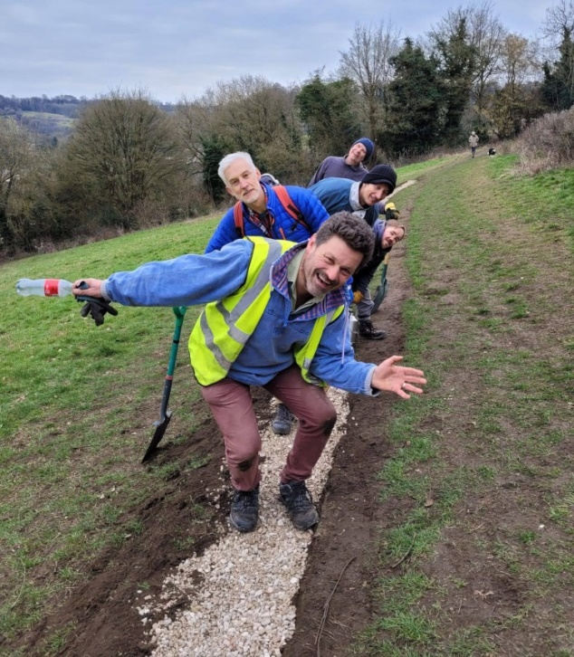
Volunteering isn’t just about hard work – Photo: Jackie Terrett
Please come and join us. No previous experience is required, it’s great exercise and very sociable! We typically meet on Sundays 10:00-12:00. If you or any family or friends are interested in getting involved, please contact us at lyncombehillfields@gmail.com
We look forward to seeing you in the fields
Very best to you all

Chris, Maurice and Anita
Friends of Lyncombe Hill Fields
Our Wild Hilltop Paradise

Editor: Ruth Herrlinger

