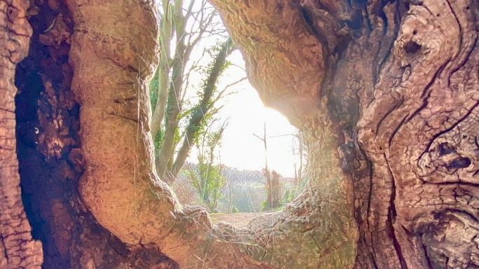
A walk around Lyncombe Hill Fields Nature Reserve

June 10 @ 7:00 pm – 9:00 pm
Join us for a gentle walk to explore the diverse habitats within our 10-acre nature reserve, just a short distance from the centre of Bath. Highlights include a visit to our Miyawaki forests, watching scything and mowing in the wildflower meadow, a peek into one of our ponds, and a visit to the tree nursery. Refreshments will be provided, giving you the chance to chat with our volunteers. Our guides will be happy to answer your questions.
Book your (free) place by emailing lyncomehillfields@gmail.com
Accessibility information. The fields are steep and are not wheelchair accessible. We will be walking on made up paths for most of the time. Public toilets are available in Alexandra Park, about 10 minutes’ walk away. This will be a walk with plenty of stops along the way.
Travel information. We will meet at the gateway opposite 100 Greenway Lane, BA2 4LN. What3Words: many.policy.fluid.
Access by foot. Walk up Lyncombe Hill, and then Greenway Lane. Buses (D2, 171, 172, 173, 174 and 522) stop at Bear Flat and at the Devonshire Arms. Parking is available in Alexandra Park. Bikes can be locked to the gate on Greenway Lane where we are meeting.
www.friendsoflyncombehillfields.co.uk

A Festival of Nature 2026 Event

@FestOfNature #FestivalofNature

